2023
UTE
MEMBER
APPRECIATION
EVENT



When: Tuesday June 20, Wednesday, June 21 from 1:30 to 3:30, and
Thursday, June 29 from 1:30 to 3:30
What: Ice Cream Treats for members of UTE Local 00051
Where: On Aldridge Street (north side of the building), between the 2 driveways
Cost: Free for UTE Members
Why: To remind you that your Union appreciates, respects, and values the work you do day-in and day-out.

How to participate:
This year’s event is being held on 3 different days; however, you can only participate and get your treat on one of the days.
On the day you choose to participate, please come to the tent on the boulevard and see a UTE council member. To receive a red ticket, you will need to provide your PSAC #, home e-mail address, home address, and personal phone number.

You will exchange that ticket with the vendor for one of the following items:
- any size slush - icebergs - cartwheels - sundaes
- cones with toppings (choc. Dip, nuts, sprinkles) - popsicles

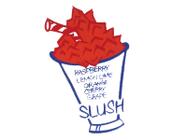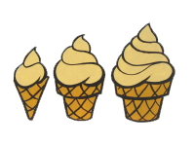
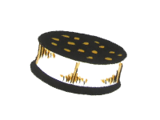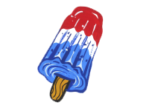

For available flavours, please go to www.kingkone.ca and click on Products. Banana Boats and Milkshakes are not available for this event.

We ask that you come out to the trucks during your afternoon break. Please be mindful of cars on the driveways and roadways.

