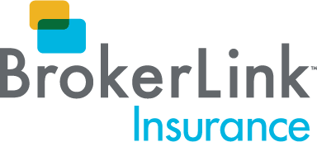



Strong winds are expected throughout Ontario today. These winds may cause widespread damage and power outages throughout our communities. Our top priority is the safety and security of our customers.

You may contact your insurance company directly, or by following the links below if you need to submit a claim.

  Intact Personal Claims
  Intact Business Claims
  Visit Intact Client Centre
  24-hour Emergency Claims: 1.866.464.2424
  Economical Auto Claims
  Economical Property Claims
  24-hour Emergency Claims:
  1.800.607.2424

  Wawanesa Auto Claims
  Wawanesa Property Claims
  24-hour Emergency Claims: 1.844.929.2637
  Gore Mutual Personal and Business Claims
  24-hour Emergency Claims: 1.844.974.4673

  Travelers Personal and Business Claims
  24-hour Emergency Claims:
  1.800.661.5522
  Aviva Personal Claims
  Aviva Business Claims
  24-hour Emergency Claims:
  1.866.692.8482

  Trillium Mutual Personal and Business Claims
  Emergency After-Hours Claims:
  1.800.235.8784
  The Kings Mutual/Heartland Farm Mutual Auto, Property and Business Claims
  24-hour Emergency Claims:
  1.800.565.7220

If you have any questions or concerns, please contact us at 1.833.847.8771.

BrokerLink.ca | Blog
﻿

 ‌ ‌ ‌ ‌

©2022 Brokerlink Inc. ™BrokerLink & Design is a trademark of Brokerlink Inc. All rights reserved.

